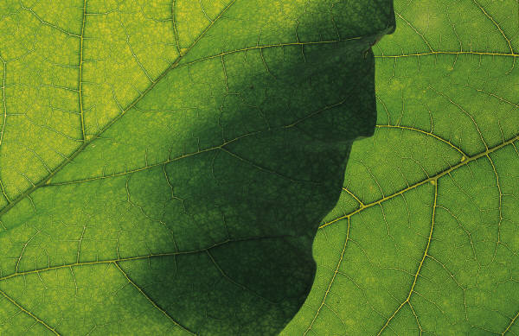
Louisa Ulrich-Verderber
1364 Castle Road Fairfield VT
(802) 782 0220
louisa.uv@gmail.com

EDUCATION
Clarkson University:
Bachelor of Science in Engineering
Engineering and Management Class of 2020
GPA: 3.853
Bellows Free Academy:
Class of 2016
15 college credits Advanced Standing.

EXPERIENCE:
2017:
- Featured on Clarkson University’s Website for innovative work. (x)
- Made a Presidential List Scholar at Clarkson University
- Made a Dean’s List Scholar at Clarkson University
- Won fourth place at the Free Enterprise Marathon
- Won second place in the Speak Off at the Free Enterprise Marathon
2016:
  - Launched Undula Tech LLC September 2016.
  - Designed and built the Undula Generator (patent pending).
2015:
  - Keynote speaker for the annual corporate meeting of 800 executives of EF Educational First Corporation, the largest international education company in the world, in Boston MA (video).
  - Won the top prize in the Vermont Makers Faire, received $5000 to develop my design: the "Wind Wing Generator."
  - VT Channel 15 TV interview for an hour-long program about my artistic work. (video)
  - Received the EF Global Citizen Scholarship – An educational tour of Europe, global summit, and speaking engagement.
  - Introduced Sir Ken Robinson, the keynote speaker, on-stage for a conference of 1,500 people, at the EF Educational Summit in Davos, Switzerland. (video)
  - Castleton University:
    - Course: Buddhist Art and Architecture, Grade: A
    - Course: Buddhist Philosophy, Grade: A
  - Vice President National Art Honor Society at Bellows Free Academy from March to June.
2014:
  - Won The United Way Festival of Lights “People’s Choice Award” for donating a sculpture.
  - University of Chicago:
    - Course: Astrophysics of the Stars, Grade: A
  - Received the St. Laurence University Book Award, a $10,000 scholarship.
  - WCAX Television Newscast featured my artistic works. (video)

2013
  - Designed and Created a public art installation. A 12ft message board/town sign for the town of Fairfield’s 250th birthday – valued at $8,500.
  - University of Chicago:
    - Course: Biotechnology, Grade: A-
  - Won Best Writing Piece in Vermont from the Classical Association of New England.
  - Introduced the Governor of Vermont at the Signing of Bill 77, legislation to mandate Personal Learning Plans.
2012
  - Designed and created a public art installation. A bicycle rack for the Bent Northrop Memorial Library valued at $7,500.
2011
  - President and Founder – Be A Spark: Large metal sculptures at BEaSPARK.com.
  - Vermont Technical College:
    - Course: Entrepreneurship: Business and Organization, Grade: A
  - Received the Vermont Leadership Council Award.

ON GOING PROJECTS
  - President and Founder – The Art of Noticing, at ArtOfNoticing.com.
  - President and Founder – Beyond The Xtra Mile Learning Pathways, at BeyondTheXtraMile.com.
  - Annual sculpture donation for:
    - The United Way Festival of Trees - raised $4,900.
    - The Homeless Shelter/Battered Women’s Shelter Auctions – raised $1,440.
    - The Vermont Symphony Orchestra, The Lake Champlain Trust, and Chamber of Commerce – raised $3,800
    - The Make a Wish Dinner - raised $2,210.

INTERNATIONAL EXPERIENCE & SPECIAL SKILLS
  - I have Dual citizenship - US and Ireland – and carry both passports.
  - I have been traveling to places like the Kalahari Desert, the Andes of Ecuador, the most remote part of Tibet, quiet corners of eastern Europe like Slovenia, Croatia, the Czech Republic and closer to home in places like Newfoundland, Northern Ireland, and Spain since the age of five.
  - Self taught IOS Swift, the Apple coding for App Creation.
  - Self taught to use Solid Works and Fusion 360.
  - Self taught computer coding and built a large website to be seen at BeyondTheXtraMile.com.
  - I can weld using both MIG and ARC machines.

